|  |  |
| --- | --- |
| ACC NavVision licences Manual | |
|  | |
|  |  |

|  |  |
| --- | --- |
| Publication type: | Licenses Installation Manual |
| Publication number: |  |
| Title: | ACC-NavVision-licenses-Manual v1.1.20 |
| Subject: |  |
| Issue: | 1.1.20 |
| Publication date: | November 20, 2012 |
| Total number of pages: | 19 |
| Author: | VCMM Kerckhaert |

Table of contents

Page #

Figures 4

Tables 4

References 6

Introduction 7

About the installation manual 7

Abbreviations list 8

Safety instructions 9

Revision history 9

1. Keys 10

1.1 Introduction 10

1.2 Starting 10

2. Licenses 10

2.1 Website 10

2.2 Licenses 11

2.3 Heritage 12

3. How to add licenses 13

3.1 Introduction 13

3.2 Licenses 13

3.3 Licenses for additional keys 17

4. Additional actions 18

4.1 Introduction 18

Figures

Figure 2‑1: login screen 11

Figure 2‑2: license keys 11

Figure 2‑3: License key page 12

Figure 2‑4: heritage 13

Figure 3‑1: AMCS main workstation 14

Figure 3‑2: AMCS mimic main workstation 14

Figure 3‑3: Communication licenses 15

Figure 3‑4: Accept billing 16

Figure 3‑5: mimic amount 16

Figure 3‑6: additional costs 16

Figure 3‑7: inherited licenses 17

Figure 3‑8: Licenses additional keys 18

Figure 4‑1: ini file download 18

Figure 4‑2: Licenses 19

Tables

Table 2‑1: license page explanation table 12

Table 3‑1: License declarations 17

**NOTICE**

**This document contains proprietary information.**

**No part of this document may be photocopied, reproduced or translated into another language without the prior written consent of   
Free Technics B.V.**

References

N/A

Introduction

The NavVision program works with special dongle-keys which provides a licensing system by which only obtained modules of the system will be available. To open this modules for a project of a single key it is necessary to apply licence information to the system. These licenses can be obtained at Imtech through a special procedure which will be described in this manual

About the installation manual

The installation manual contains the following chapters:

* Chapter “Keys” presents information about use of keys in the system
* Chapter “licenses” gives an instruction on how to obtain and install licenses.
* Chapter “exceptions” contains an overview of the main exceptions and technical data.

Abbreviations list

Safety instructions

*NOTE:  
This section provides only a summary of the most important safety requirements and notes, which will be mentioned in the individual sections. To protect your health and prevent damage to the devices, it is essential to read and carefully follow the safety instructions.*

The indications NOTE, CAUTION and WARNING have the following significance:

*NOTE:  
An operating procedure, practice or condition etc., which it is essential to emphasize.*

**CAUTION**

**An operating procedure, practise or condition etc., which, if not strictly observed, may damage or destroy equipment.**

**WARNING**

**An operating procedure, practise or condition etc., which, if not carefully observed may result in personal injury or loss of life.**

Revision history

Revisions issued since publication.

|  |  |  |  |
| --- | --- | --- | --- |
| **Issue** | **Date** | **Revision** | **Reason** |
| 1.1.20 | March 5, 2014 |  | First release |

# Keys

## Introduction

NavVision is protected by the use of usb-dongles. These dongles, together with a unique license number, will open the viewers, communication etc. on the system for the specific computer that contains the key and the licenses.

## Starting

When a project is started, keys will be provided for every workstation. Initially these keys will be empty. No licenses will be attached to the key, nor will there be a project number connected to the keys.

To get the proper licenses for these keys, an application need to be made to obtain a project number for these keys. With this project number you will get access to the license system to obtain the right licenses for the specific keys. To get a project number you will need to send an Email to [Stefan.Verdel@imtechmarine.com](mailto:Stefan.Verdel@imtechmarine.com). This Email must contain the following information:

* Own project number
* Installation (build, ship’s name or other identification)
* The number on the keys that you are going to use
* Customer- client information (if not yet available)

A new password will be created in the license-system and send to the client. Together with the project number it will provide access to the specific keys of the installation.

An installation is one ship/platform and contains 1 master key and, depending on the range, one or more sub keys for the other workstations. A project can consist of more than one installation.

# Licenses

## Website

Once you have obtained the project number and password you can log in on the website https://service.freetechnics.eu/license/. You will get the following screen:

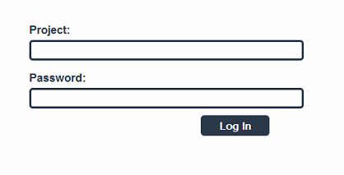

Figure 2‑1: login screen

Log in with the project number and the password that were provided to you. You will get to the page that shows the keys that were assigned to your project.

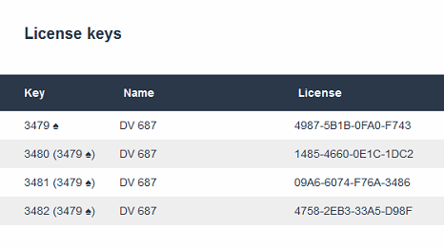

Figure 2‑2: license keys

Master keys are identifiable by the spades-sign behind the key number. Sub keys have the master key between brackets behind the key number.

## Licenses

Once you click on a certain key, a new page will appear. Here you can identify the licenses that you need.

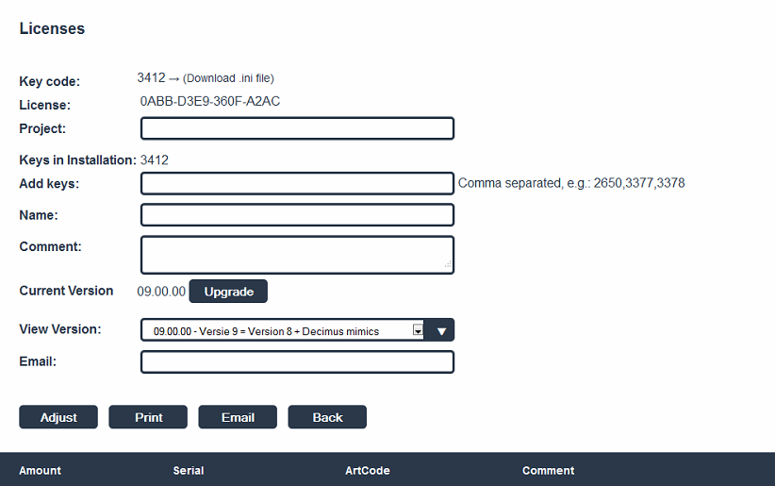

Figure 2‑3: License key page

Here you will find your key code, the project number, name, comments, version number etc. Do not change anything here unless you are sure what you are doing.

|  |  |
| --- | --- |
| Field | Explanation |
| Key code | Code of the key |
| License | License number |
| Project | Project number |
| Keys in installation | All the keys in the installation |
| Add keys | Add a key |
| Name | Name of ship or project |
| Comment | Comment |
| Current version | Current NavVision version |
| View version | Choose version |
| Email | Provide email |
| Adjust | Adjust (after changing licenses) |
| Print | Print the licenses |
| Email | Email the licenses |
| BacK | Back |

Table 2‑1: license page explanation table

## Heritage

In the license structure there are two possible ways to inherit licenses.

1. From master key to sub key: communication, configuration and interface licenses under the AMCS group, will be inherited from the master key.
2. Under the heritage structure it is possible that one license will free other, underlying licenses to all the other keys.

Licenses in the AMCS structure will free other underlying licenses. In the future these AMCS licenses will be the only licenses you need. Until then we will show all underlying licenses automatically in green as shown in the following picture:

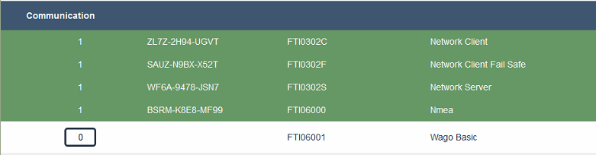

Figure 2‑4: heritage

# How to add licenses

## Introduction

Once you have obtained the keys and the password for the website it is time to assign the licenses to the diverse keys. For this it is important that you know what you need. In the new license system it will be a lot easier because you only have to choose a few things.

## Licenses

For the master key (the one with the spade behind it) you will assign the main AMCS licenses for that key by choosing the FTI0500 AMCS Main Workstation (see Figure 3‑1). While we have one main workstation in an installation, you can fill in “1” here.

If mimics are provided on the main workstation, you will have to choose the FTI05200 Mimic Main Workstation. Here you will assign how many mimics you want on the main workstation. Let’s say you want 12 mimics, then you fill in “12” here (see Figure 3‑2).

For the interfaces you need to fill in the amount of interfaces that you have in the installation. For the serial link you need to fill in all the serial links that are used in the installation. This includes two serial links per Moxa. One per CAN interface, but also one per COM-port and one for every link over the network such as Modbus TCP/IP etc. (see Figure 3‑3).

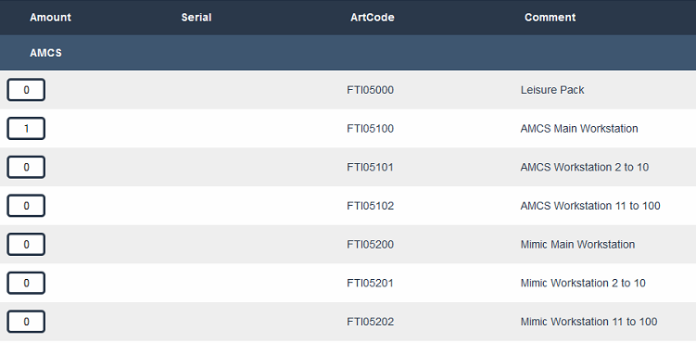

Figure 3‑1: AMCS main workstation

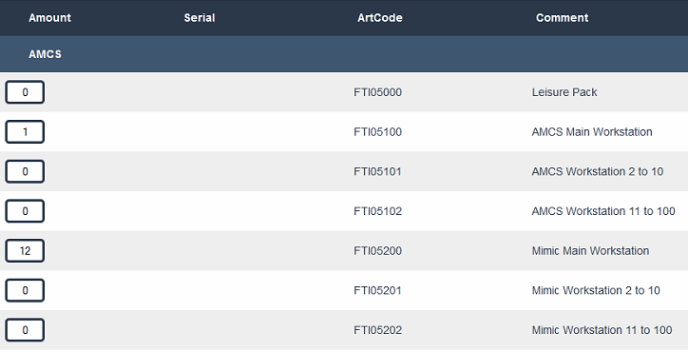

Figure 3‑2: AMCS mimic main workstation

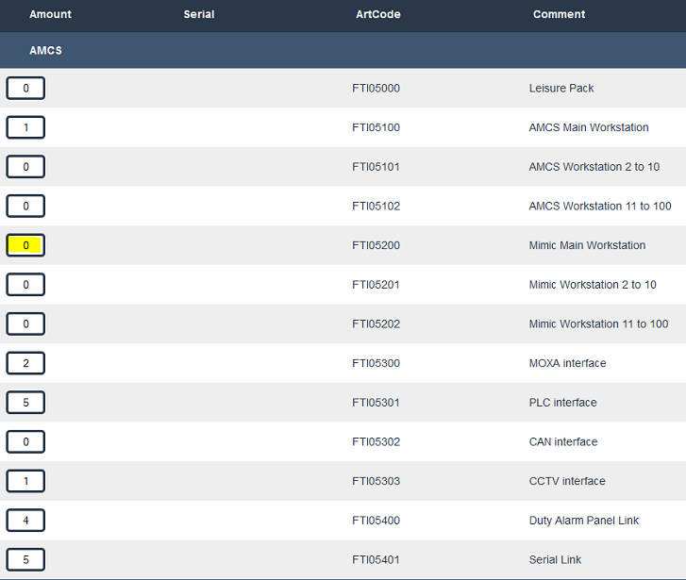

Figure 3‑3: Communication licenses

After you adjusted all the values, scroll up and click “adjust”. A pop-up will appear which will show you the price of the licenses. You will need to accept that to effectuate the licenses (see Figure 3‑4).

*: notice that you first need to accept a workstation licence and in the second run choose the amount of mimics. The program can’t assign mimics when there is not a workstation selected.*

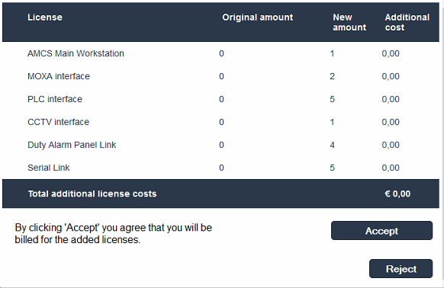

Figure 3‑4: Accept billing

After this you can add the amount of mimics and click “Adjust” again. When accepted, the mimic amount will be added to the key and the additional costs will be charged (see Figure 3‑5 and Figure 3‑6).



Figure 3‑5: mimic amount

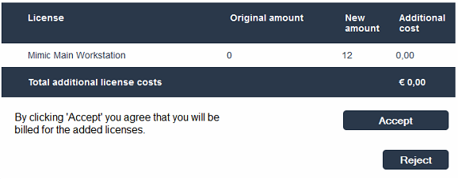

Figure 3‑6: additional costs

All inherited licenses will be green now (see Figure 3‑7). This means that all these licenses will be open on this key.

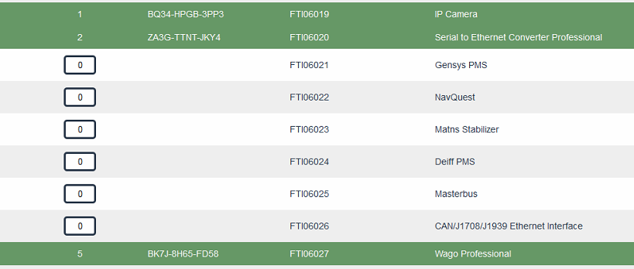

Figure 3‑7: inherited licenses

*: In the near future all these licenses will be replaced by the 5000 series licenses*

## Licenses for additional keys

For the rest of the keys in the installation you won’t choose the AMCS workstation nor the mimic main workstation. These are solely for the main key. Instead you choose for the “AMCS workstation 2 to 10” and for the mimics for the “Mimic workstation 2 to 10” (see Figure 3‑8). The rest of the licenses will be inherited from the main key.

|  |  |
| --- | --- |
| workstation | Choose |
| Main server | AMCS Main Workstation |
| Client Fail-safe | AMCS Workstation 2 to 10 |
| Client | AMCS Workstation 11 to 100 |
| Mimics main server | Mimic Main Workstation |
| Mimic client fail-safe | Mimic Workstation 2 to 10 |
| Mimic client | Mimic Workstation 11 to 100 |
| MOXA interface | AMCS Main Workstation (for other keys it is inherited) |
| PLC interface | AMCS Main Workstation (for other keys it is inherited) |
| CAN interface | AMCS Main Workstation (for other keys it is inherited) |
| CCTV interface | AMCS Main Workstation (for other keys it is inherited) |
| Duty Alarm Panel Link | AMCS Main Workstation (for other keys it is inherited) |
| Serial Link | AMCS Main Workstation (for other keys it is inherited) |

Table 3‑1: License declarations

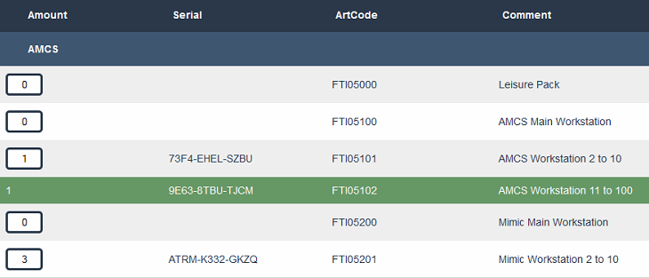

Figure 3‑8: Licenses additional keys

# Additional actions

## Introduction

Before you can use the keys you will have to put the licenses into place. You can do so by inserting them manually into NavVision. This is described in the operator’s manual. When you print or email the licenses you get a list of license numbers that you have to put in the right order into NavVision (see Figure 4‑2).

When you download the keyxxxx.uc.ini file (by clicking on the “download ini file” section see Figure 4‑1), you can put the file in the network folder on the workstation and the licenses will be imported automatically.



Figure 4‑1: ini file download

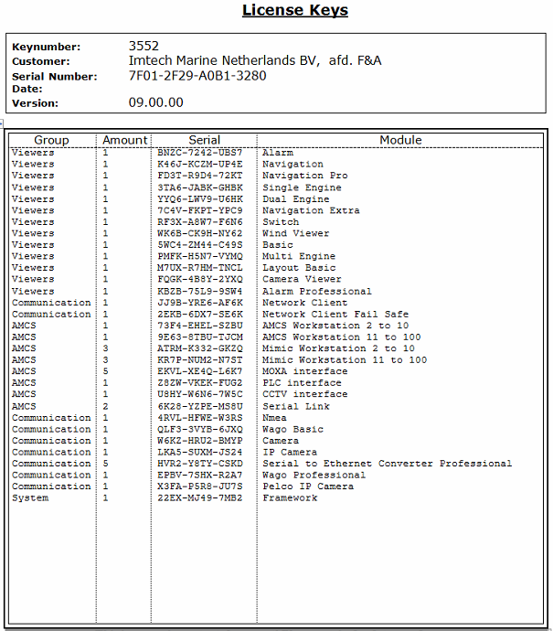

Figure 4‑2: Licenses